DAD 220

Professor Mandeh

Brian Engel

8/31/2022

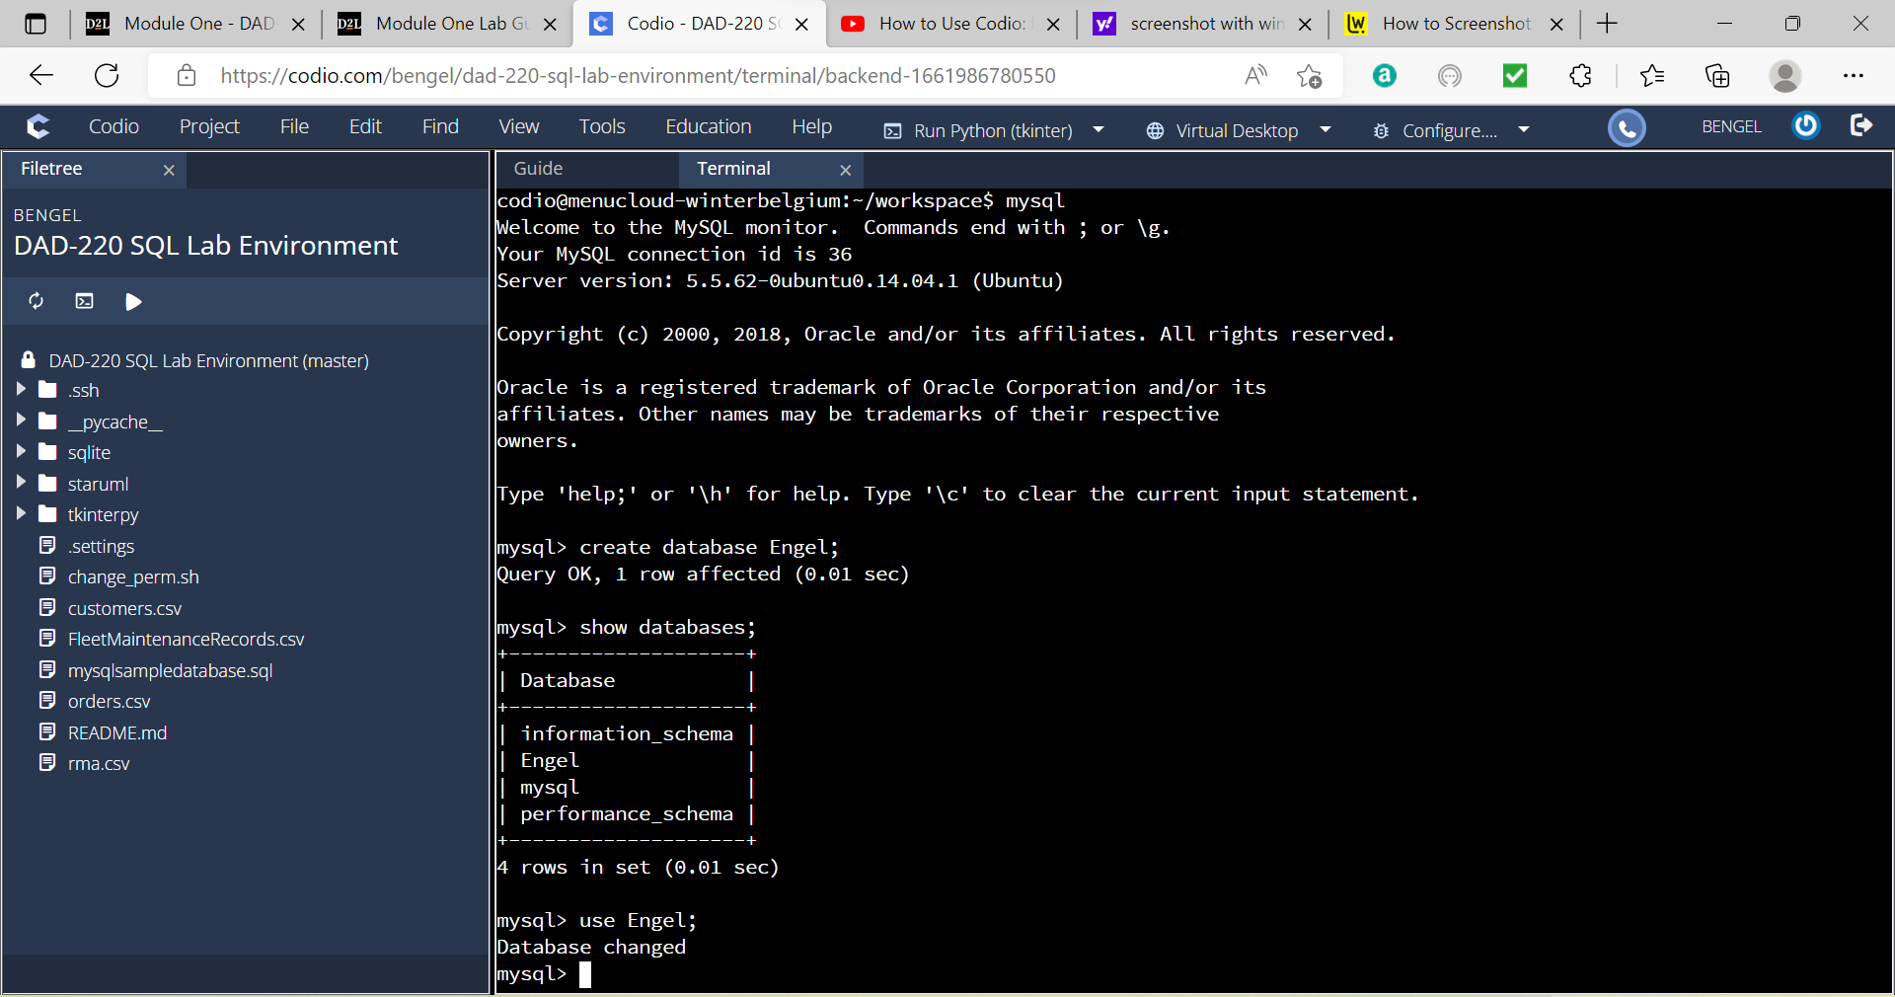

1st screenshot - Create a new database

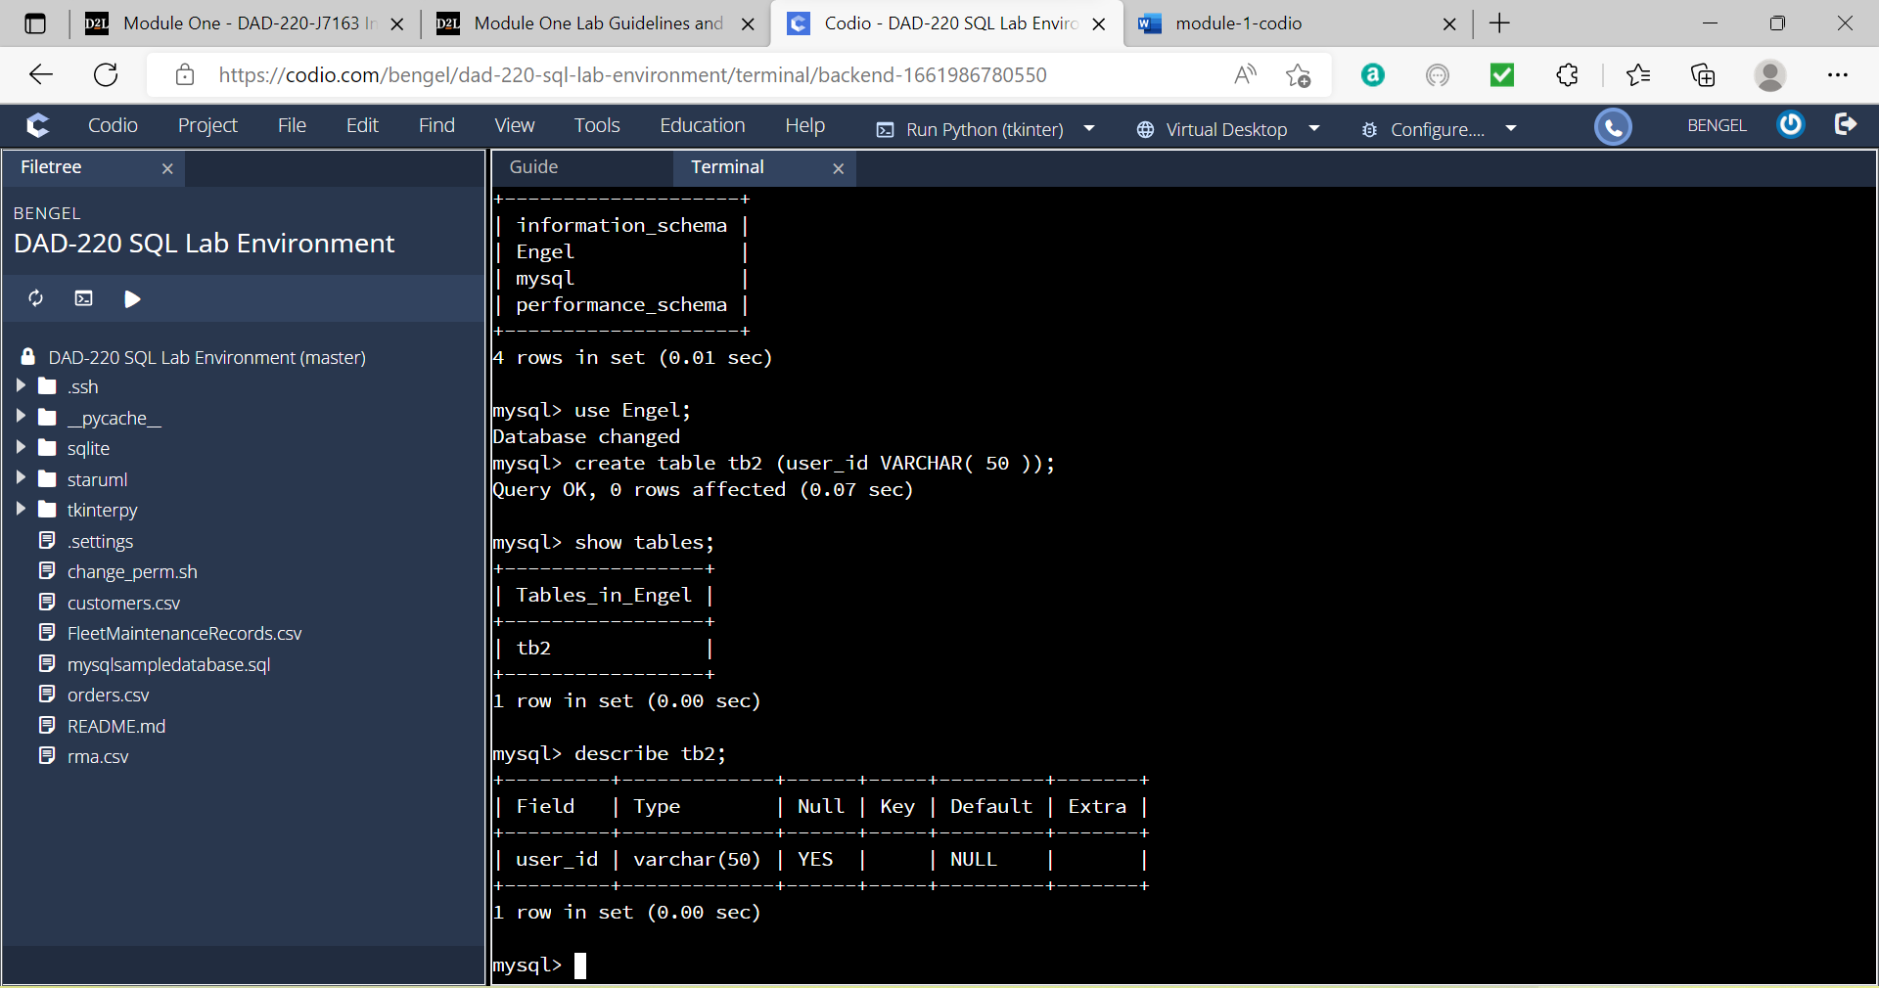

2nd screenshot - Create a table called tb2

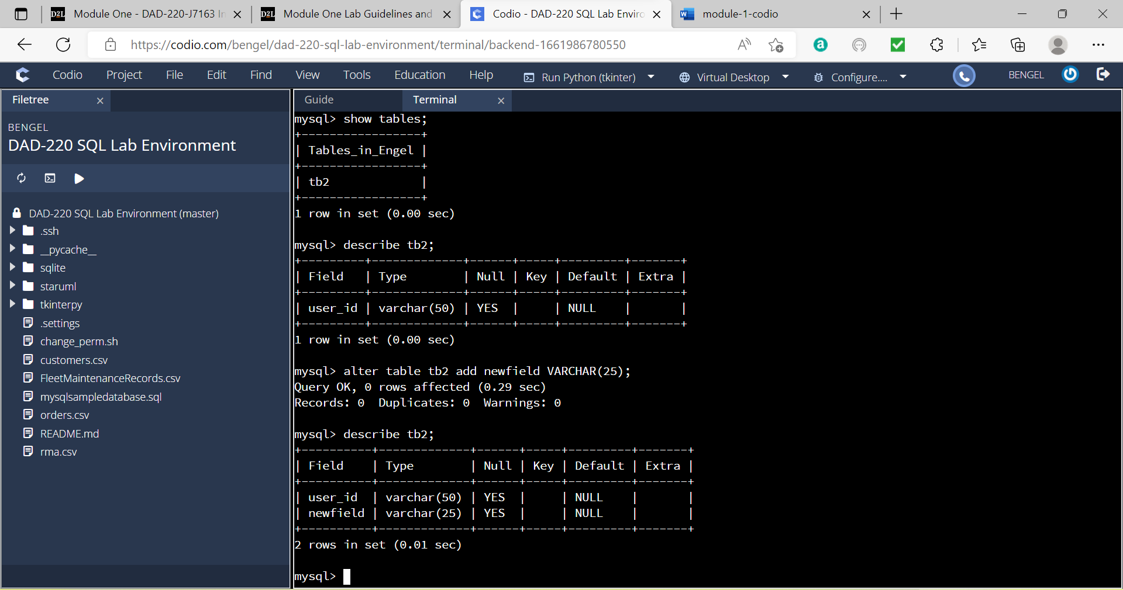

3rd screenshot – Add a second field